

**Front - End UI/UX Mini Project**

**Product Launch Page**

1. **Introduction :**

* **Project Title:** *Product Launch Page*
* **Submitted By**: 
  + *2462323 - Darren Samuel D’Cruz -* [*darren.samuel@btech.christuniverityuniversity.in*](mailto:darren.samuel@btech.christuniverityuniversity.in)
  + *2462345 - P. Kamuel Shawn -* [*p.kamuel@btech.christuniversity.in*](mailto:p.kamuel@btech.christuniversity.in)
  + *2462333 - Joel Jacob Roji -* [*joel.jacob@btech.christuniversity.in*](mailto:joel.jacob@btech.christuniversity.in)
* **Course**:  *UI/UX Design Fundamentals*
* **Instructor Name**: *Mrs. Nagaveena*
* **Institution**:  *Christ (Deemed – to – be) University, Kengeri Campus*
* **Date of Submission**: *25/09/2025*

**2. Abstract**

This project focuses on creating a responsive front-end launch page for the PulsePro X gadget. It uses five core technologies/languages: HTML5, CSS3, JavaScript, Bootstrap, and supporting libraries like Font Awesome & Google Fonts. The design emphasizes intuitive navigation, responsiveness, visual hierarchy, and interactivity.

Key sections include: hero, features, specifications, testimonials, pricing, call-to-action, and footer. The page adapts seamlessly to all device sizes.

**3. Objectives**

* Design an intuitive, visually appealing interface
* Build a fully responsive page using modern front-end technologies
* Use semantic HTML5 for structure and accessibility
* Style the page with CSS and Bootstrap
* Add interactivity using JavaScript/jQuery
* Include typography and icons with Google Fonts and Font Awesome

**4. Scope of the Project**

* Front-end development only
* Responsive across desktop, tablet, and mobile
* No backend integration
* Open-source libraries and pure code usage

**5. Tools & Technologies Used**

| Tool/Technology | Purpose |
| --- | --- |
| HTML5 | Page structure and content |
| CSS3 | Styling, layout, and responsiveness |
| JavaScript / jQuery | Interactivity and animations |
| Bootstrap 5 | Grid System, components, utility classes |
| Google Fonts & Font Awesome | Typography and icons |

**6. HTML5 – Structure and Semantic Content**

* Provides the core structure of the webpage.
* Uses semantic tags (<header>, <section>, <nav>, <footer>) for clarity and accessibility.
* Defines headings, paragraphs, lists, and tables to organize content meaningfully.
* Improves SEO and screen reader accessibility.
* Ensures each section (hero, features, specifications, testimonials, pricing, CTA, footer) is well-defined.

**7. CSS3 – Styling, Layout, and Visual Design**

* Controls colors, typography, spacing, alignment, and layout.
* Creates a modern, professional, and consistent design.
* Implements Flexbox and Grid for responsive layouts.
* Adds visual hierarchy, making headings, buttons, and cards stand out.
* Enhances user engagement with hover effects, transitions, and card animations.
* Ensures readability and accessibility across all devices.

**8. JavaScript / jQuery – Interactivity and Dynamic Behavior**

* Adds dynamic behavior to the webpage.
* Enables smooth scrolling between sections when navigation links are clicked.
* Implements CTA interactions, e.g., alert messages on button clicks.
* Prepares the page for future interactive enhancements like modals or animations.

**9. Bootstrap 5 – Responsive Layouts and Prebuilt Components**

* Provides a responsive grid system for flexible content arrangement.
* Offers prebuilt components (navbar, buttons, tables, cards) for faster development
* Uses utility classes for spacing, alignment, shadows, and rounded corners.
* Ensures consistent design and mobile-friendly layouts.
* Works alongside CSS3 to balance custom styling and framework efficiency.

**10. Supporting Libraries – Google Fonts and Font Awesome**

* Google Fonts: Provides modern, readable fonts (e.g., Poppins) for typography and visual hierarchy.
* Font Awesome: Offers vector icons to visually represent features (battery, health, connectivity).
* Enhances user comprehension by providing visual cues.
* Adds professional look and feel without heavy custom design.
* Ensures consistency in style and branding across the page.

**11. Key Features**

| Feature | Description |
| --- | --- |
| Responsive Design | Flexbox + Bootstrap grid ensures adaptability |
| Smooth Navigation | Fixed nav + jQuery scroll |
| Interactive Cards | Hover effects on features, pricing, and testimonials |
| Typography & Colors | Readable fonts, high-contrast buttons |
| CTA Buttons | Engaging call-to-action to boost user interaction |

**12. Challenges Faced & Solutions**

| Challenge | Solution |
| --- | --- |
| Fixed nav overlapping content | Added top padding to sections (padding-top: 100px) |
| Aligning multiple cards | Flexbox with wrapping and max-width constraints |
| Responsive images | Used img-fluid class |
| Font scaling | Used relative units (em/rem) instead of px |
| Smooth scrolling | Implemented jQuery .animate() |

**13. Outcomes Obtained :**

* Responsive Design Achieved: The page adapts seamlessly to desktops, tablets, and mobile devices.
* Clear Visual Hierarchy: Headings, buttons, and sections are organized for easy readability and user guidance.
* Interactive User Experience: Smooth scrolling, hover effects, and CTA buttons enhance engagement.
* Semantic and Accessible HTML: Proper use of HTML5 tags ensures accessibility for screen readers and better SEO.
* Professional Aesthetic: Use of CSS3 styling, Bootstrap layout, and supporting libraries (Google Fonts & Font Awesome) creates a modern, polished appearance.
* Structured Layout: Sections like hero, features, specifications, testimonials, pricing, and call-to-action are clearly defined, improving content flow.
* Reusable Components: Feature cards, pricing plans, and testimonial cards are modular, allowing easy updates in the future.
* Hands-On Learning: Team gained practical experience in front-end development, responsive design, and integration of multiple technologies.

**14. Future Enhancements**

* JavaScript Enhancements: Add modals, sliders, interactive product previews, and dynamic content loading.
* Backend Integration: Implement payment gateway functionality for real purchases.
* Advanced Animations: Include CSS or JavaScript animations for smoother transitions, scroll-based effects, or card reveals.
* Theme Options: Add light/dark mode toggle for better accessibility and user preference.
* Form Integration: Include contact forms or newsletter subscriptions with backend validation.
* Enhanced Accessibility: Improve ARIA labels, keyboard navigation, and contrast for visually impaired users.
* Performance Optimization: Minify CSS/JS, optimize images, and improve page load times.
* SEO Improvements: Implement meta tags, structured data, and rich snippets for better search engine visibility.

**15. Sample Code - Screenshots :**

* **HTML code:**

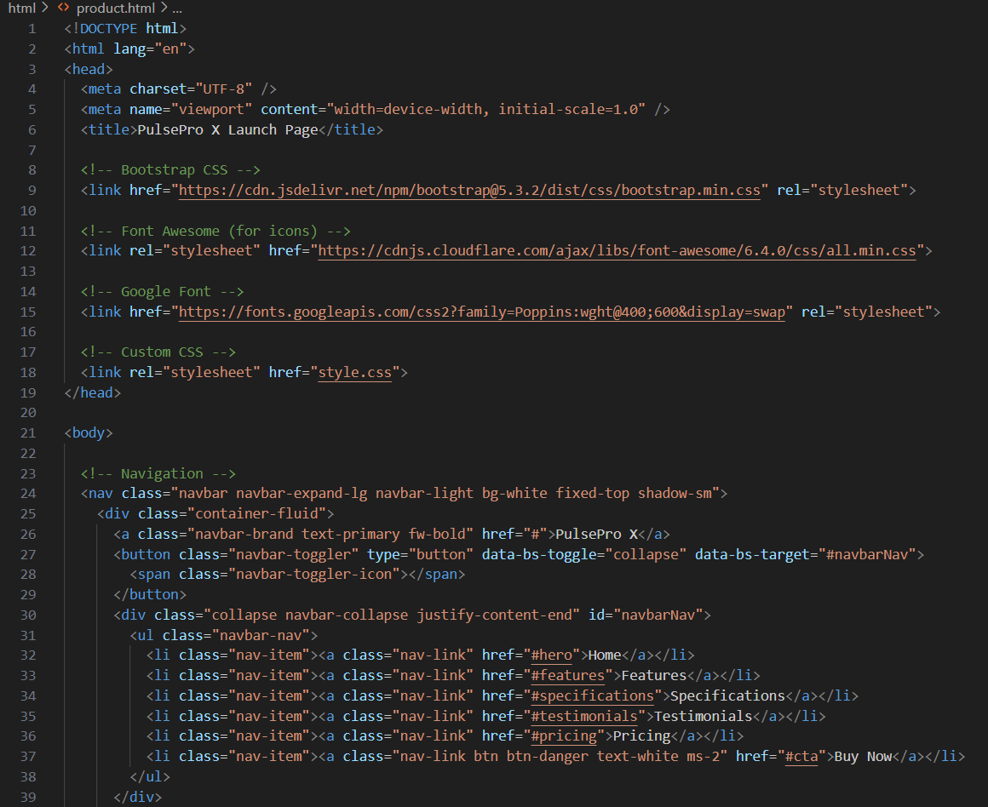

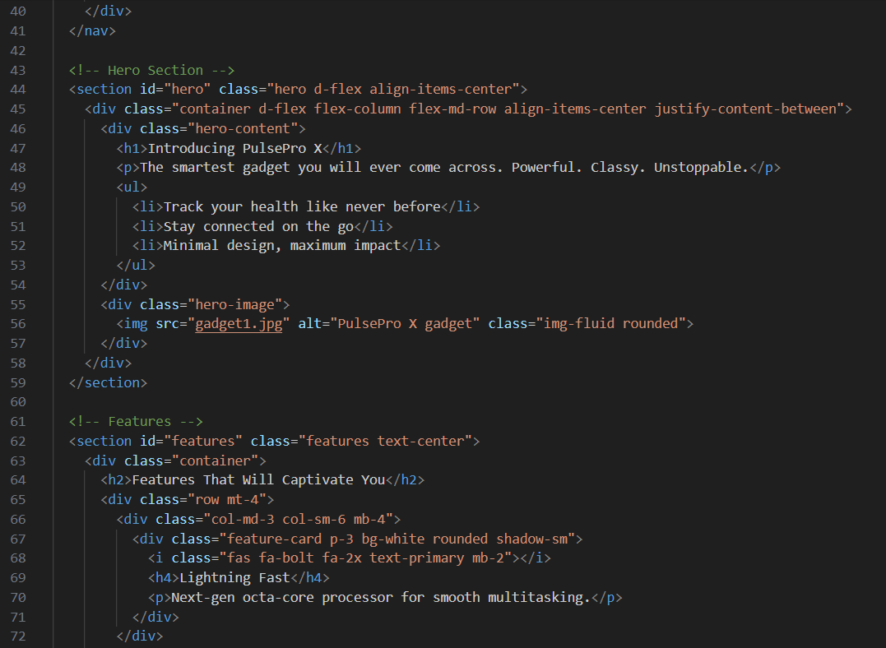

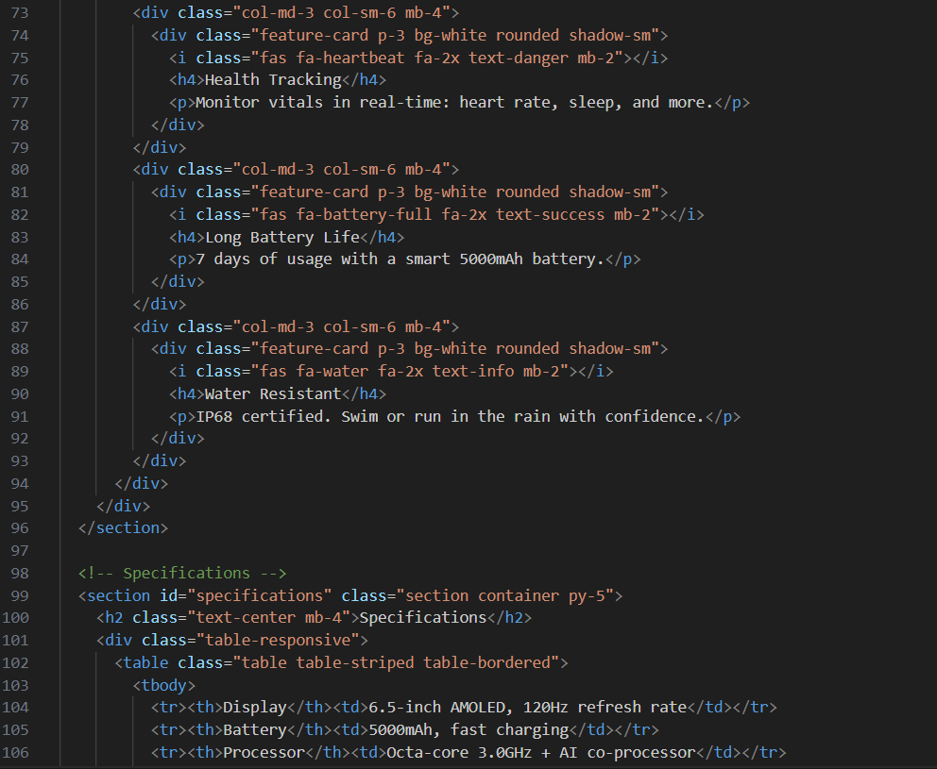

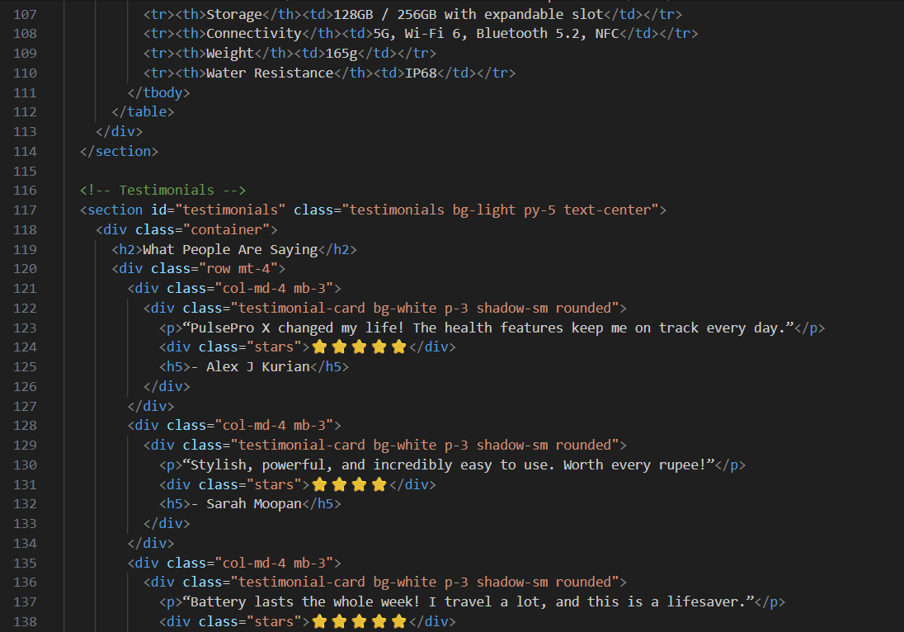

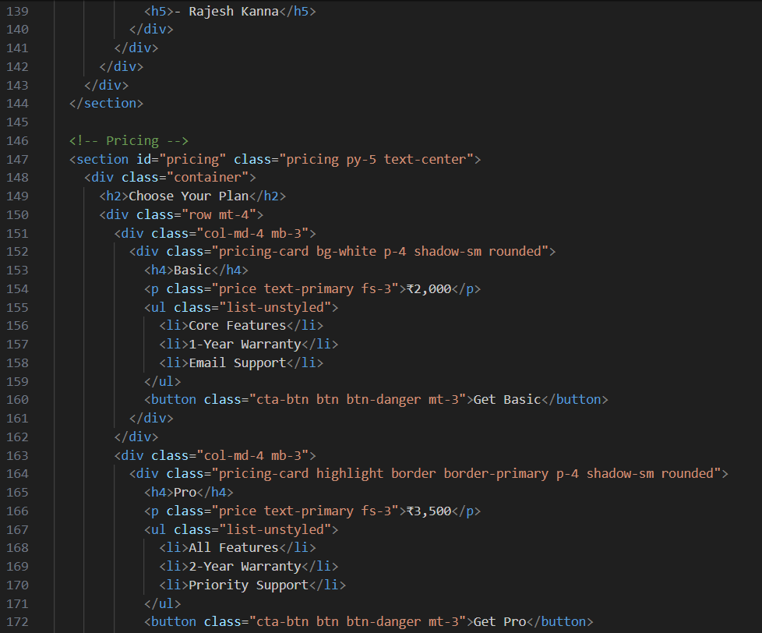

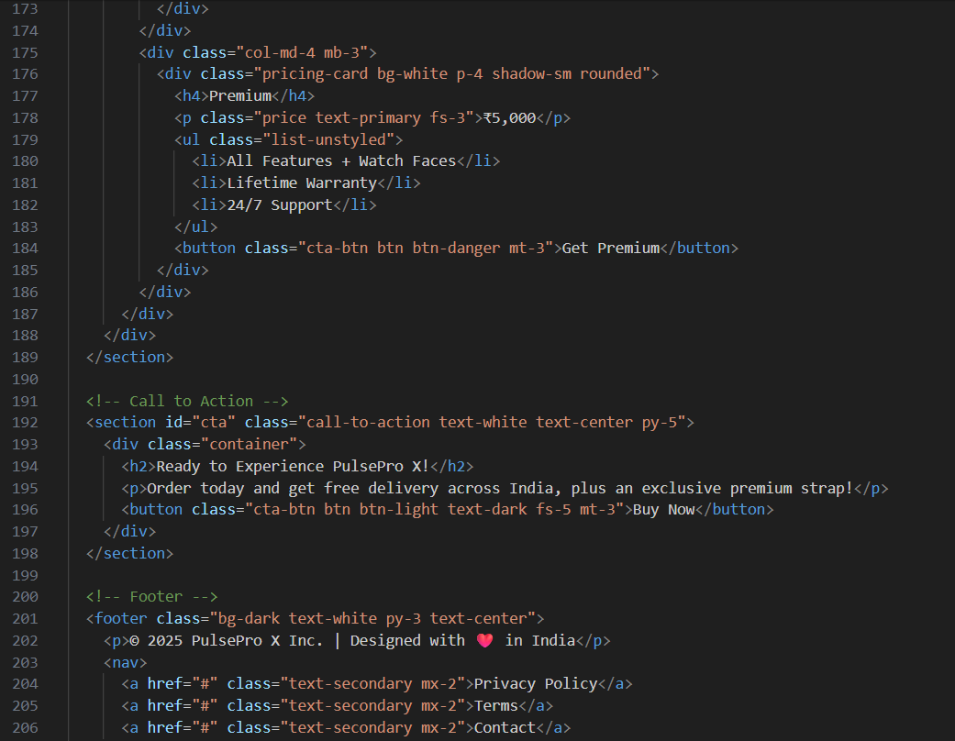

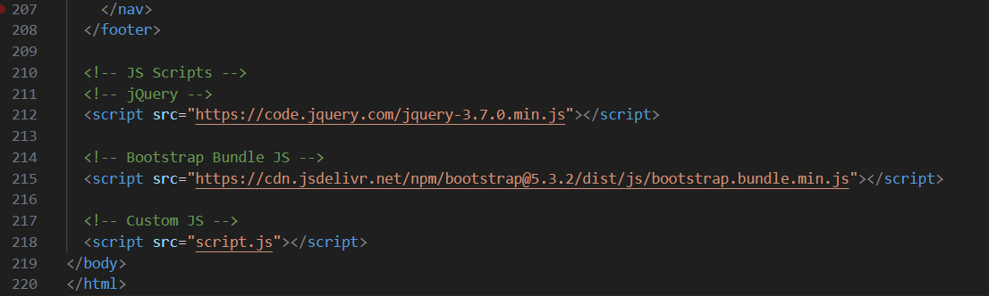

* **CSS Code:**

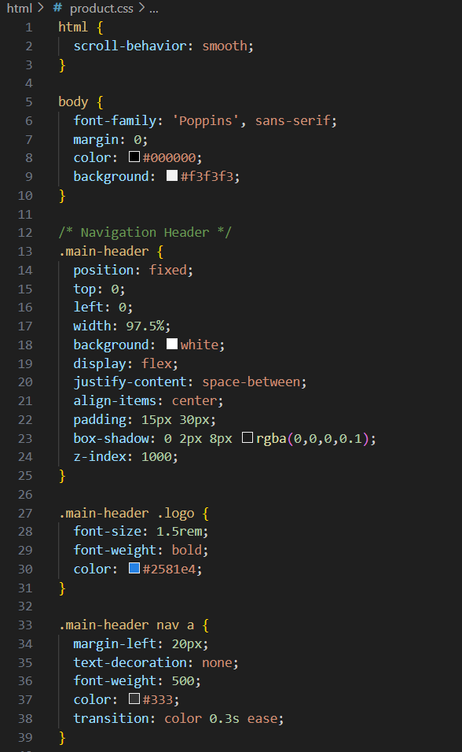

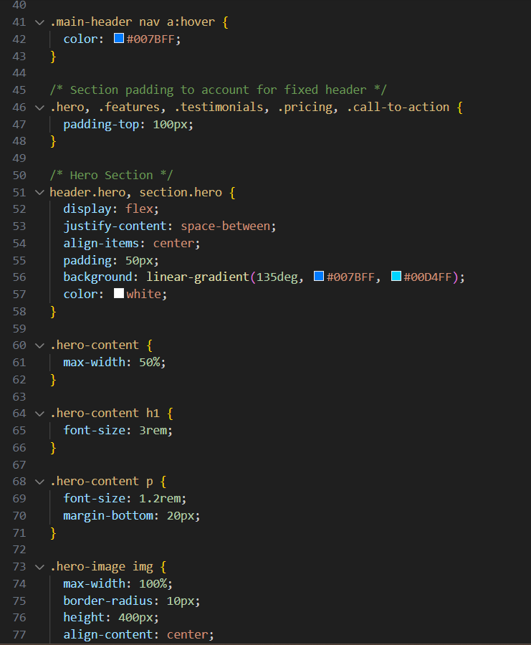

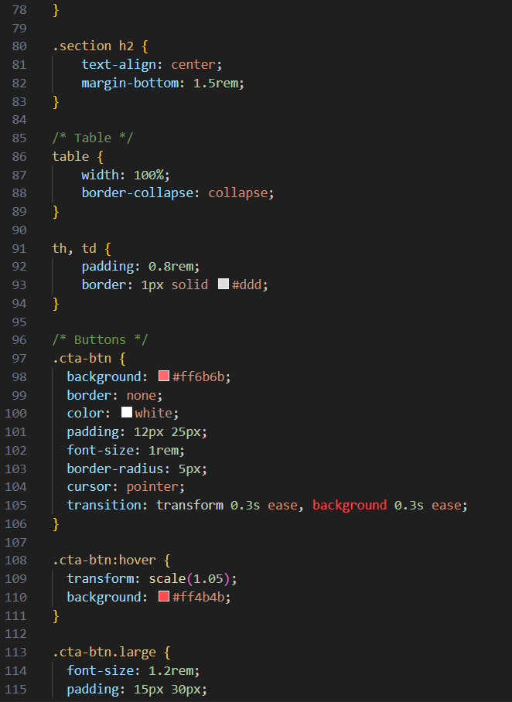

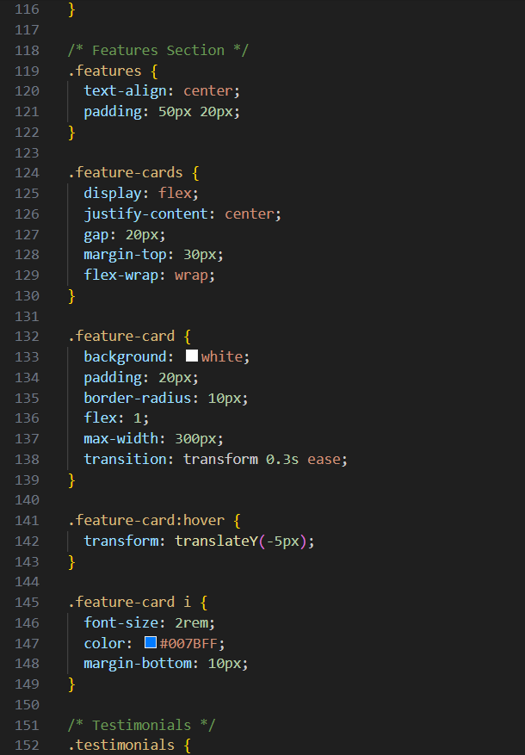

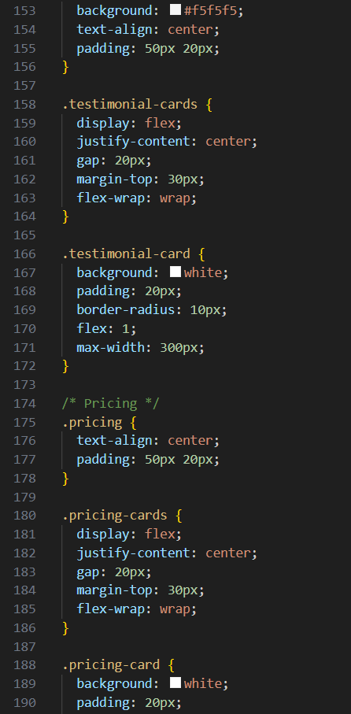

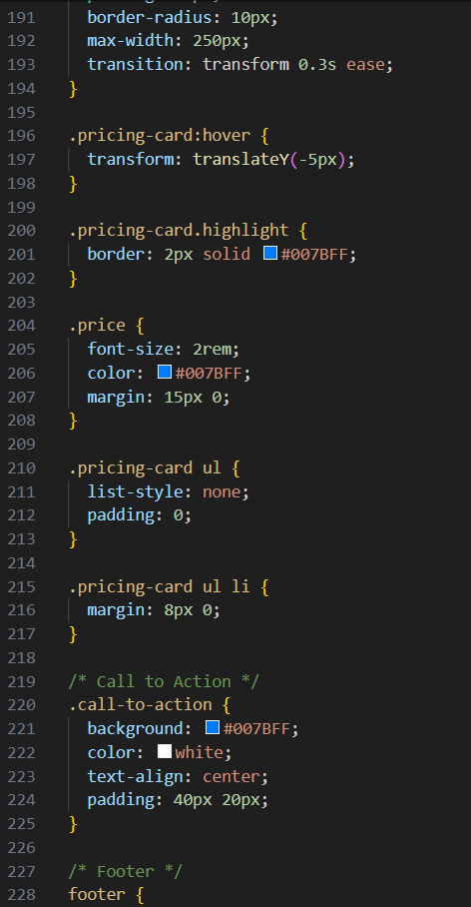

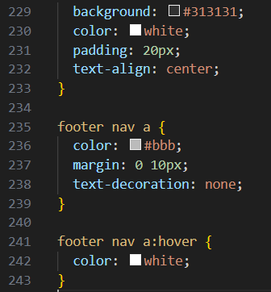

* **JavaScript Code:**

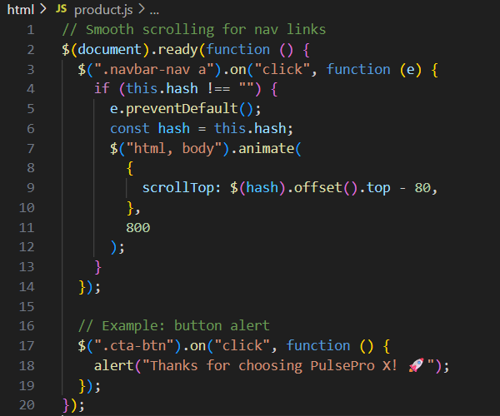

**16. Screenshots of Final Output Page :**

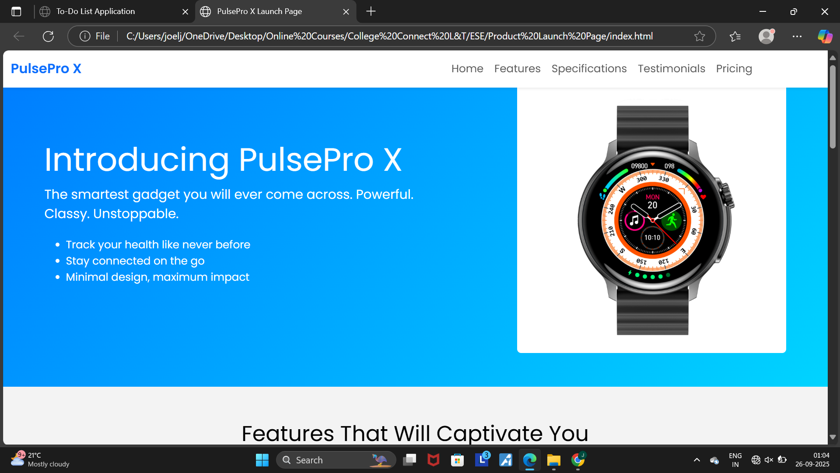

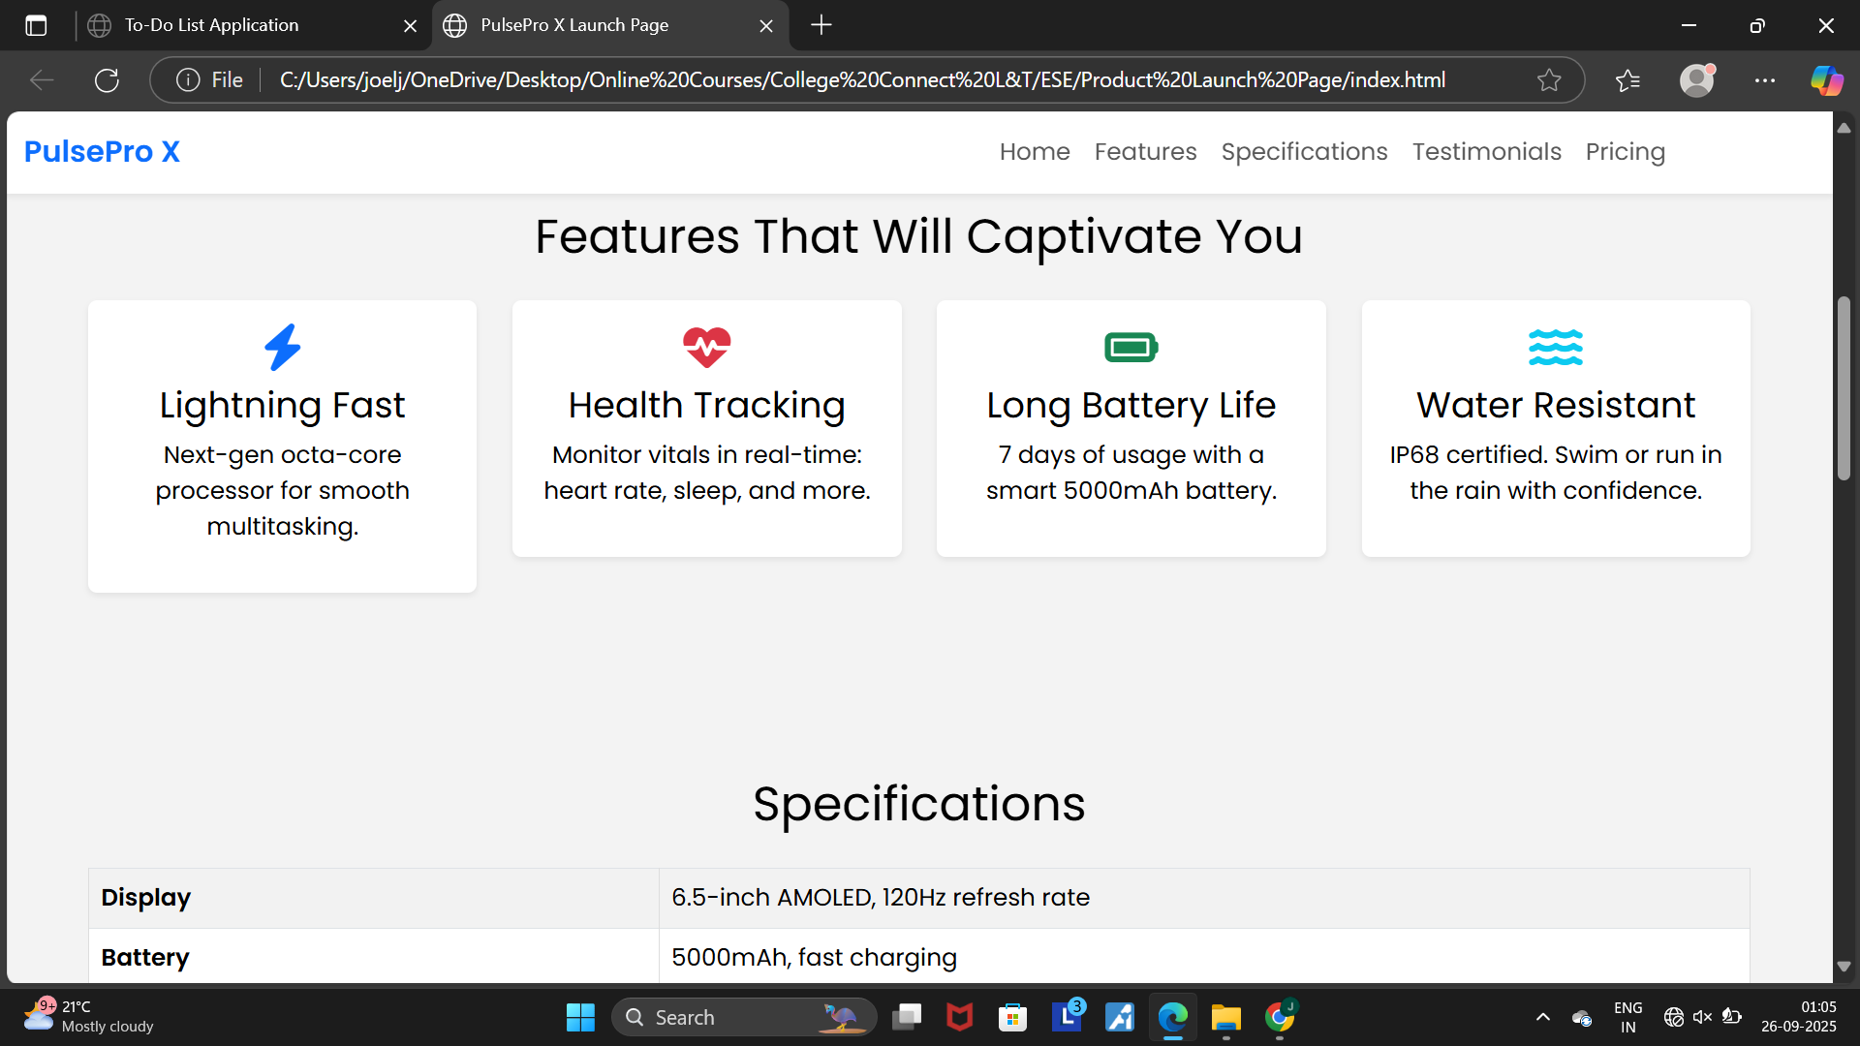

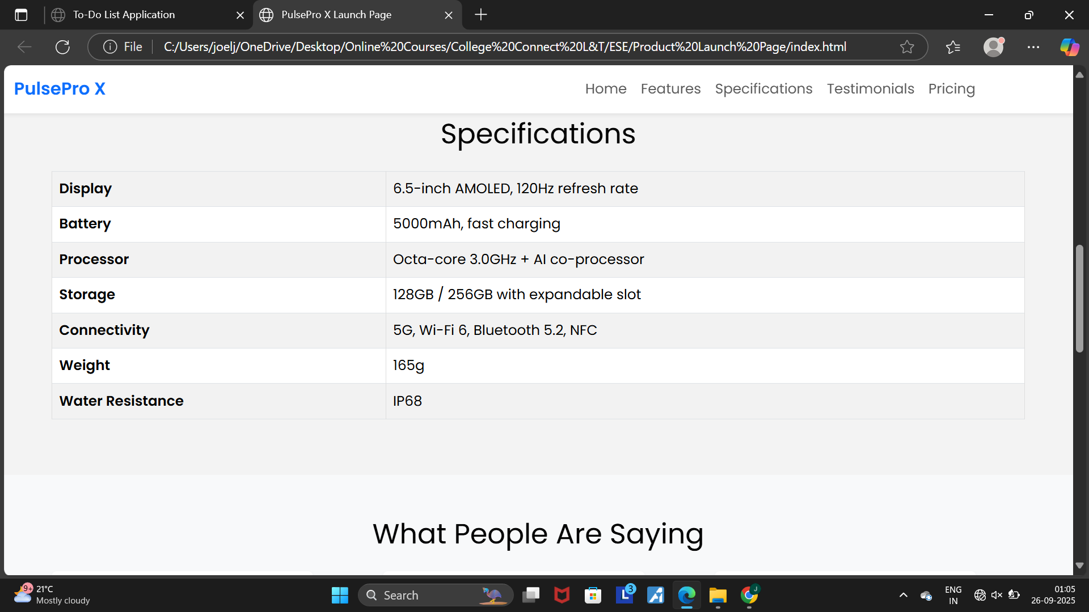

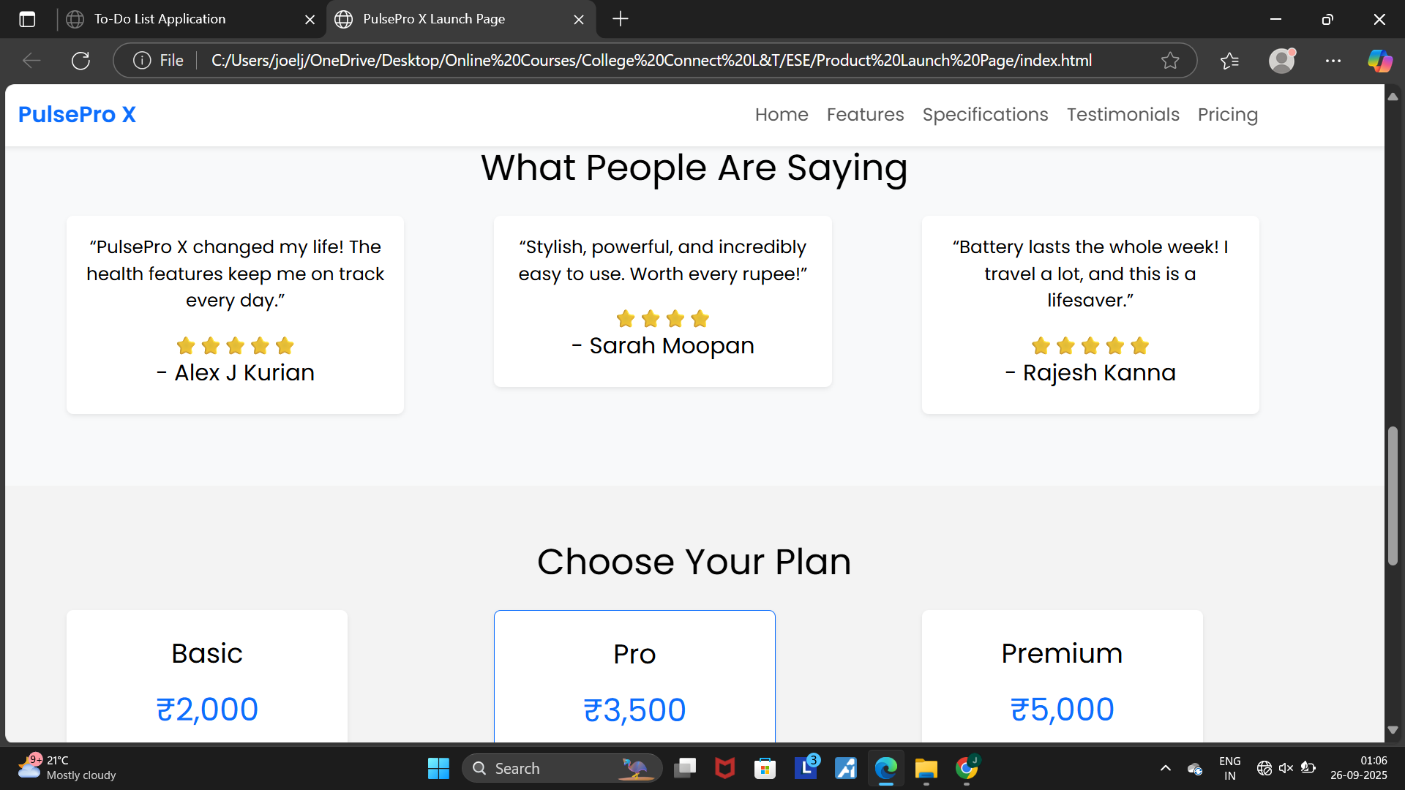

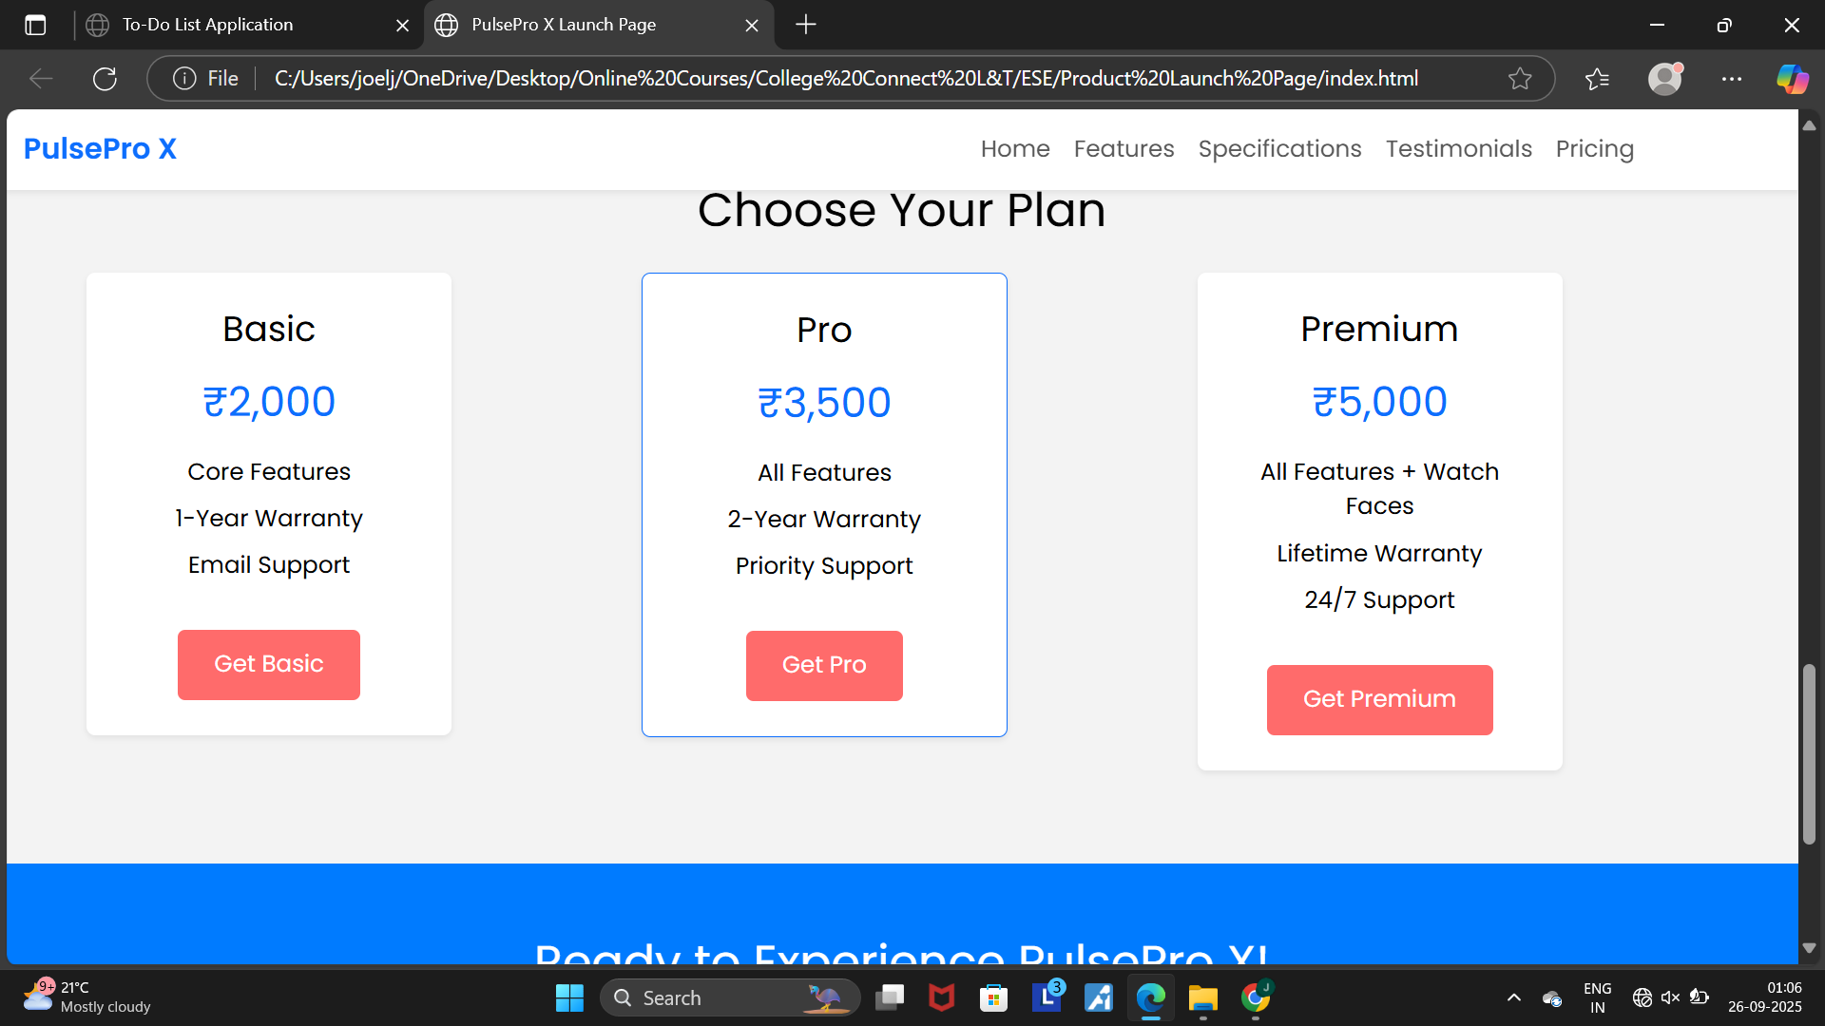

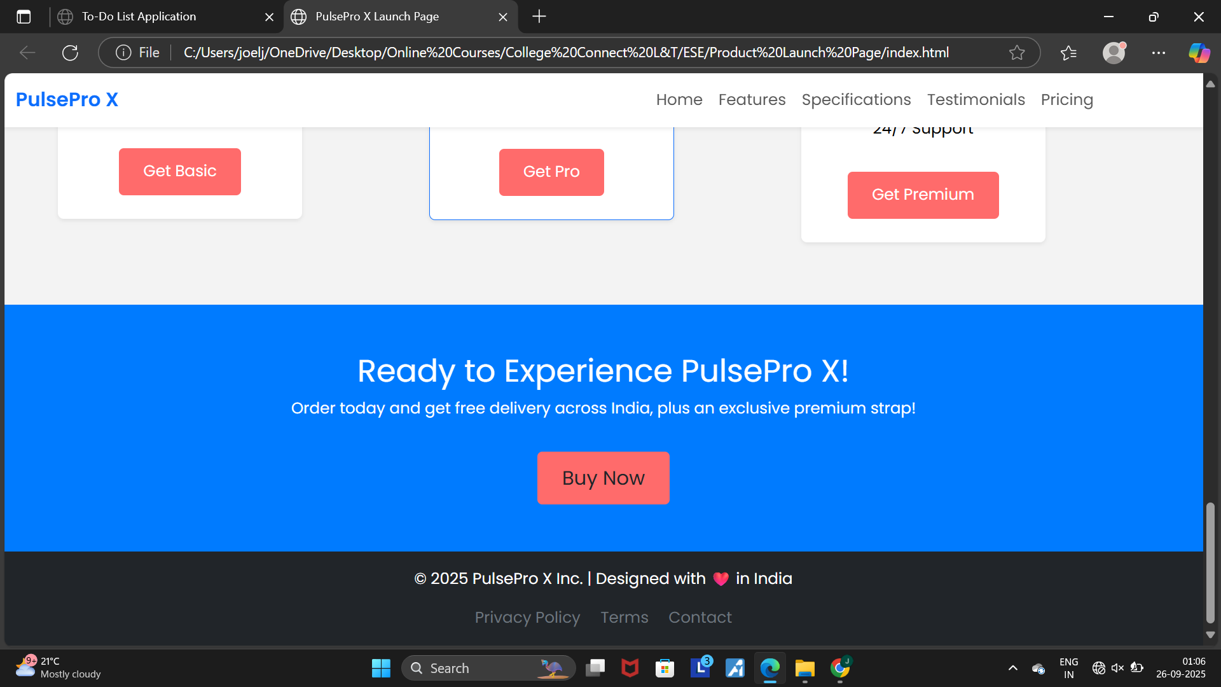

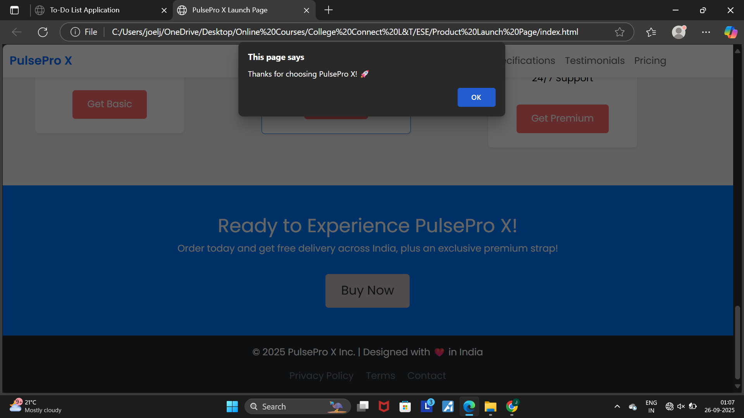

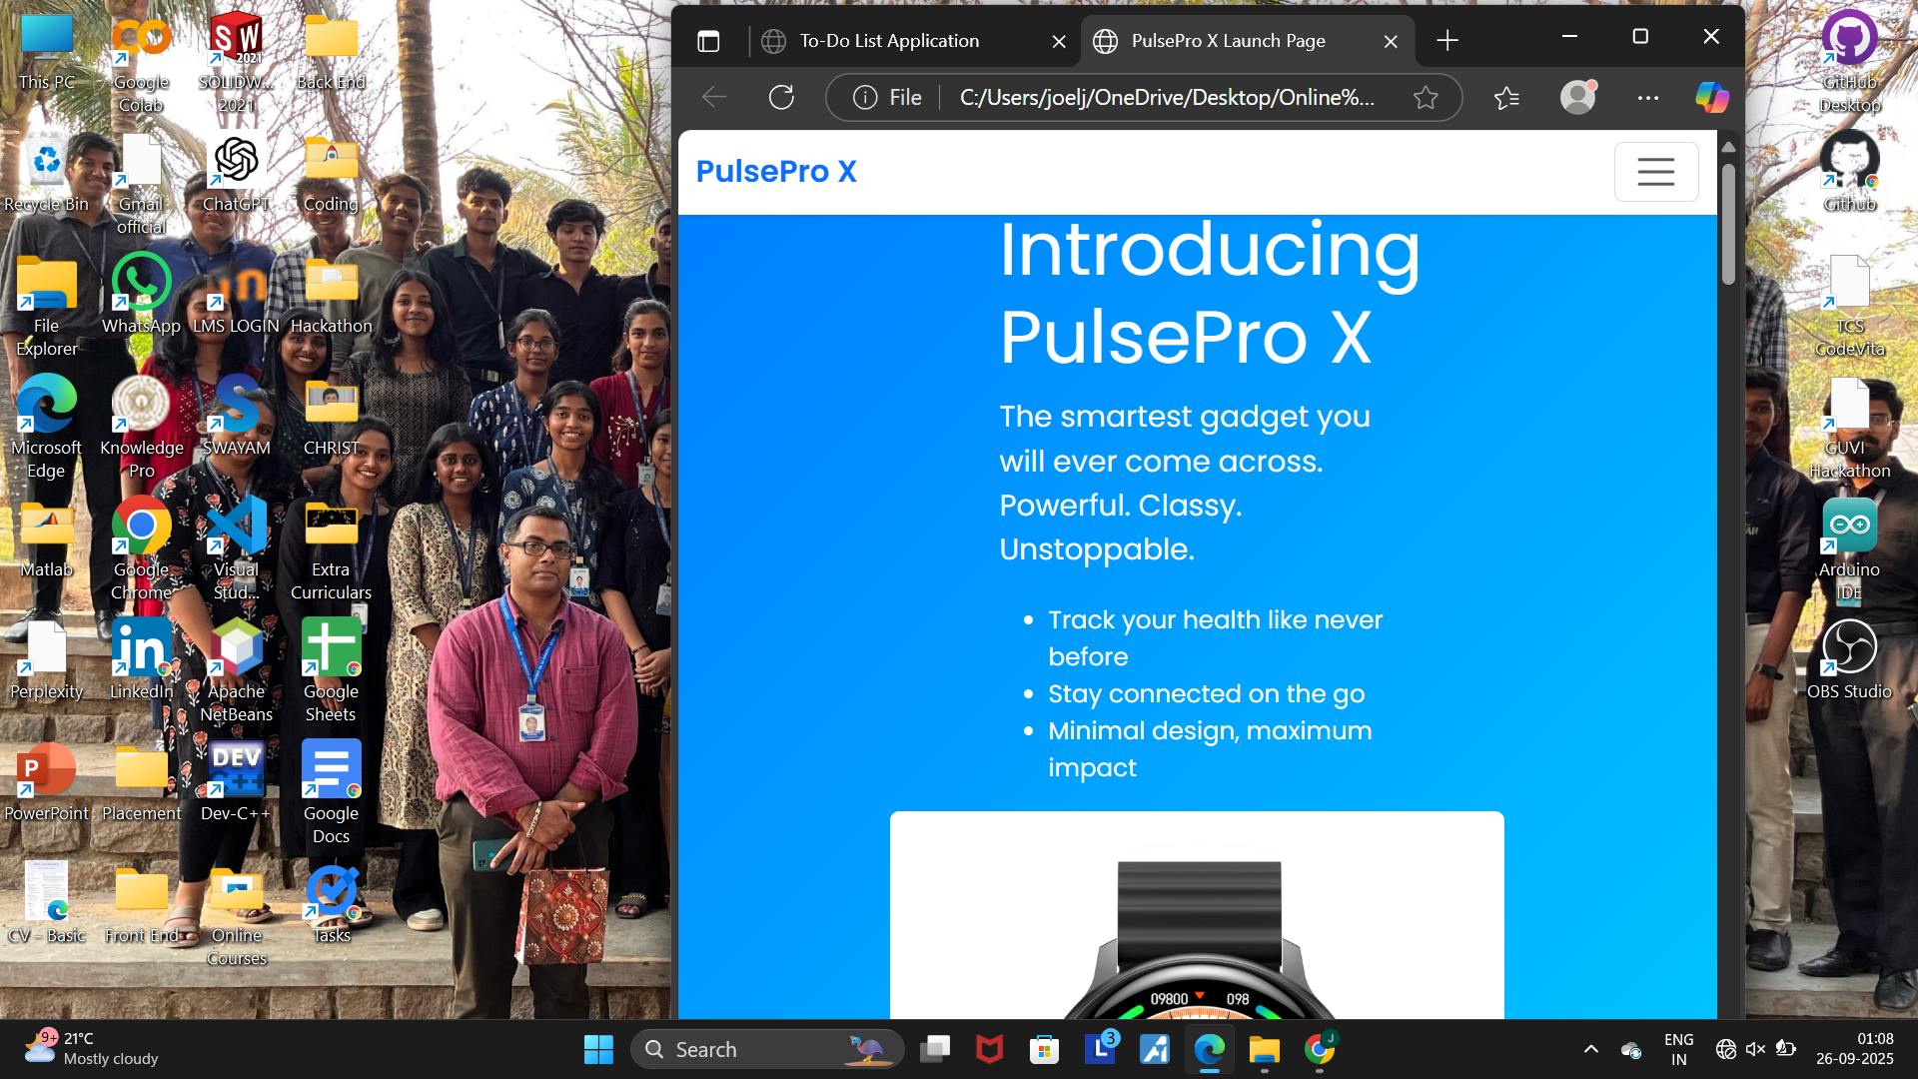

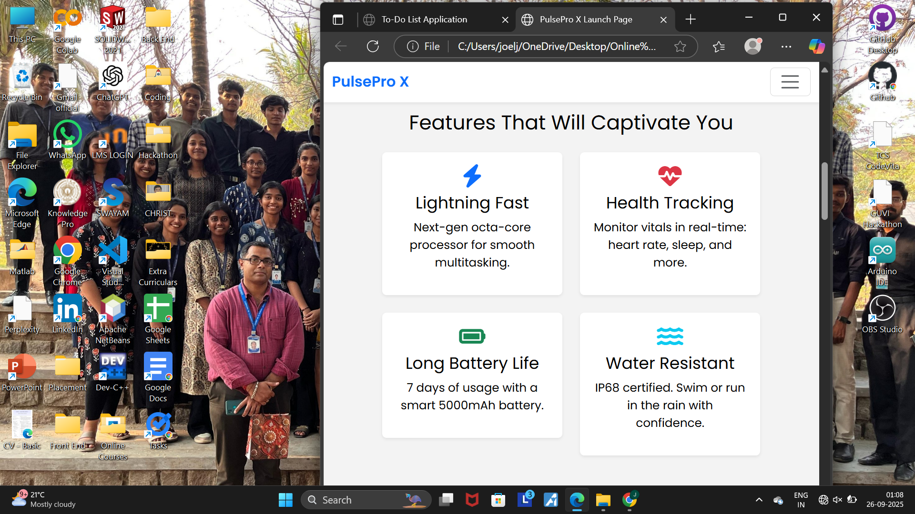

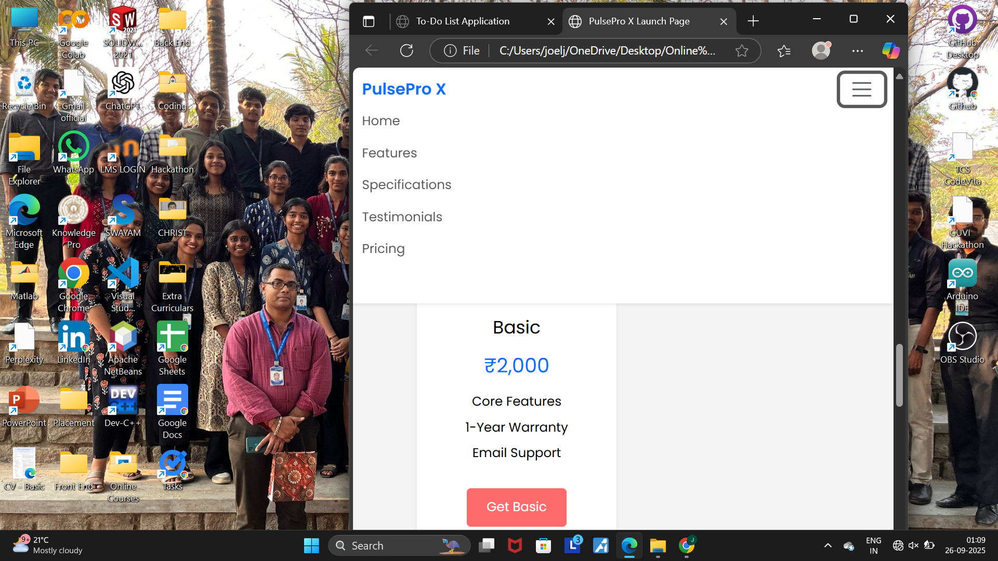

**17. Conclusion**

The Product Launch Page successfully demonstrates all five technologies:

* HTML5 for structure
* CSS3 for styling
* JavaScript/jQuery for interactivity
* Bootstrap for layout
* Google Fonts & Font Awesome for visuals

It is responsive, visually appealing, and user-friendly, aligning with professional UI/UX standards.

**18. References**

* L&T LMS: https://learn.lntedutech.com/Landing/MyCourse
* Bootstrap Documentation: https://getbootstrap.com/docs/5.3/getting-started/introduction
* Font Awesome: https://fontawesome.com/
* Google Fonts: https://fonts.google.com/